UNIT 6
People around me: Describing Physical Features

Target Skills  (Keterampilan Utama) | Reading (Membaca)
Supporting Skills  (Keterampilan Pendukung) | Listening and speaking (Mendengarkan dan Membaca)
Learning Objectives  (Tujuan Pembelajaran) | You will be able to: (Anda akan mampu melakukan hal-hal berikut)  - Describe a person: Physical features (age, height, hair, weight)
Learning Activities  (Kegiatan Pembelajaran) | - Start:  Identifying a person based on physical descriptions.  - Master it:  Parts of the body: Matching pictures and words  Describing people: Choosing the right words based on the given pictures.  - Apply:  Describing people in sentences  Describing people in a paragraph  - Review:  Describing ourselves  - Take note:  Note about judging people

Let’s Start
Activity 6.1. Identifying people
Look at the pictures below and read the descriptions in each number. Write down the name of the person described. (Pelajari gambar berikut dan baca penjelasannya di tiap nomor. Tuliskan nama dari orang yang digambarkan).
Caroline
Betty
Anna

- She has straight hair. Her hair is long. (_________)

- She is wearing earrings, necklace and glasses.
Her hair is short. (_________)

- She has shoulder-length hair and she is wearing earrings. (_________)

Let’s Master it
Parts of the Body
Activity 6.2. Matching words and parts of the body
Before we learn how to describe people, we should know different parts of the body. (Sebelum kita belajar bagaimana mendeskripsikan orang, kita perlu mengenal kata-kata terkait bagian-bagian tubuh kita).

Study the following images. Match the words and the images. (Pelajari gambar berikut dan pasangkan dengan gambar terkait).
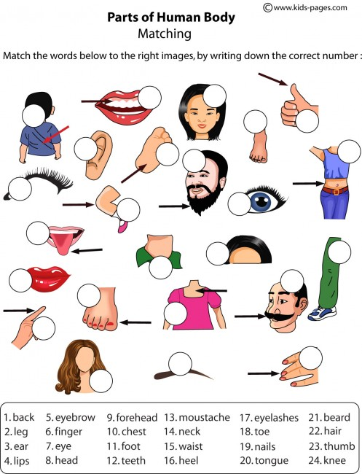

Describing People
We can describe people’s physical descriptions in many ways. Study the table below. (Kita bisa mendeskripsikan penampilan fisik seseorang dalam berbagai cara. Pelajari tabel berikut).
1. SEX | Boy, Girl, Man, Woman.
2. AGE | Baby, toddler, child, teenager, young adult, adult, middle-aged, old/young, elderly.
3. HEIGHT | Very tall, tall, fairly tall, medium/average, fairly short, short, very short
4. POSTURE | Very big, big, fairly big, plump, average/medium, fairly small, small
5. WEIGHT | Very heavy, heavy, fairly heavy, average/medium, slim, fairly thin, thin, very thin.
6. HAIR | a. Colors: black, brown, blond(e), red/auburn, grey  b. Texture: straight, wavy, curly, kinky  c. Length: short, shoulder-length, waist-length, long  d. Volume: bald, balding, thin, thick
7. EYES | a. Colors: black, brown, blue, green, gray, hazel  b. Shape: big, small, slanting
8. OTHERS | Man: beard, moustache, sideburns  Man/Woman: glasses, freckles, dimple

To learn more about physical descriptions, look at the picture below. (Untuk belajar lebih banyak tentang penampilan seseorang, perhatikan gambar berikut).
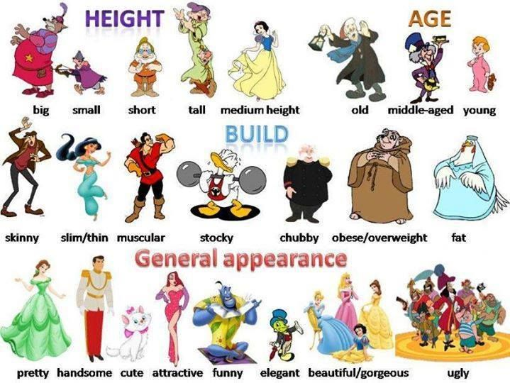

Let’s Apply
Activity 6.3. Describing People: Try This!
Describe the following people using language expressions provided. (Deskripsikan gambar berikut dengan menggunakan ungkapan yang disediakan).
 | Bob  (30 years old) | 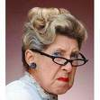  Jane  (70 years old) | Diana  (56 years old)
Physical descriptions | Bob | Jane | Diana
- Age | - Young  - Old  - Middle-aged  - Elderly | - Young  - Old  - Middle-aged  - Elderly | - Young  - Old  - Middle-aged  - Elderly
- Sex | - Male  - Female | - Male  - Female | - Male  - Female
- Hair Length | - Short  - Long  - Shoulder length | - Short  - Long  - Shoulder-length | - Short  - Long  - Shoulder-length
- Hair Texture | - Straight  - Wavy  - Curly  - Kinky | - Straight  - Wavy  - Curly  - Kinky | - Straight  - Wavy  - Curly  - Kinky
- Other features | - Earrings  - Glasses  - None | - Earrings  - Glasses  - None | - Earrings  - Glasses  - None
Activity 6.4. Choosing the best word to describe a person
Look at each picture and read the descriptions below each picture. Then circle the best word that describe the picture. (Perhatikan tiap gambar dan deskripsinya di bawah gambar. Kemudian lingkari kata yang paling tepat terkait gambar tersebut).
- Sharon is a college student. She is (young/old). She is (fat/slim) and she is (tall/short). She has (long/short) hair. Her hair is (wavy/straight).

- William is a musician. He is (young/old). He is (tall/short). In addition, he is also (fat/thin/slim). He has (straight, wavy) hair. His hair is (thick/thin)

- Helen is a florist. She is (young/old). She is (tall/medium height/short). She is (fat/average weight/thin/slim). She has (big/small) eyes and her hair is (short/long).

Activity 6.5. Describing a person
Look at each picture! Then, write three to five sentences to describe the person in each picture. You can look at the previous activity to see an example on how to describe the physical feature of a person. (Perhatikan tiap gambar! Lalu, tuliskan tiga sampai lima kalimat yang menggambarkan orang ditiap gambar. Anda bisa melihat kembali kegiatan sebelumnya untuk melihat contoh bagaimana menuliskan deskripsi fisik seseorang).

Roger | Claire | James
Roger is ____ | Cailre is _____ | James is ____

Let’s Review
Activity 6.6. Describing ourselves
Now, use the words that you have just learned to describe about yourself. (Sekarang, gunakan kata-kata yang baru saja anda pelajari untuk mendeskripsikan anda sendiri).
Draw your picture here! | Describe yourself here in 3 to 5 sentences.  - (height) I’m _______ cm tall  - (weight) I weigh ____ kgs.  - (posture) I’m ________  - (hair length) I have _____ -length hair  - (hair type) I have _____ hair

Let’s Take Note
Activity 6.7. Quotation
Read the explanation of a quote below. Which quote does it explain? (Baca penjelasan dari ungkapan berikut. Mana yang paling tepat menjelaskan ungkapan tersebut?)
- There is a silver lining behind every dark cloud.
- When there is a will, there is a way.
- Don’t judge a book by its cover.

Can you think of some examples that we can do to implement this life lesson? (Bisakah anda memberikan contoh-contoh lain bagaimana kita menerapkan pelajaran hidup seperti ini?)

