UNIT 3
My Hobbies and Interests

Target Skills  (Keterampilan Utama) | Speaking and Reading (Berbicara and membaca)
Supporting Skills  (Keterampilan Pendukung) | Listening and writing (Mendengar dan menulis)
Learning Objectives  (Tujuan Pembelajaran) | You will be able to: (Anda akan mampu melakukan hal-hal berikut)  - Mention different types of hobbies and interests (menyebutkan berbagai jenis hobi dan minat)  - Ask for common hobbies and interests (menanyakan tentang hobi dan minat)  - Answer questions about hobbies and interests (Menjawab pertanyaan tentang hobi/minat).
Learning Activities  (Kegiatan Pembelajaran) | - Start:  - People and their hobbies and interests  - What do you like doing? Other hobbies and interests  - Master it:  - Comprehending the model dialog  - Using language expressions to talk about hobbies/interests.  - Apply: A conversation about hobbies and interests  - Answering questions  - Mini dialogs  - On your own  - Review: Discussion questions  - Take note: Hobbies and interests as conversation starters.
Let’s Start
Activity 3.1. Matching pictures and hobbies/interests
Look at the pictures. Match each person with his or her hobbies and interests. Look at number 1 as an example. (Bacalah penjelasan tentang tiap orang di bawah ini, dan pasangkan tiap orang dengan hobi dan minat mereka dengan mencantumkan. Lihat nomor 1 sebagai contoh.)
- Painting C. Gardening E. Cooking
- Photography D. Reading F. Playing guitar
Picture 1  (C. Gardening) | Picture 2  (________________) | Picture 3  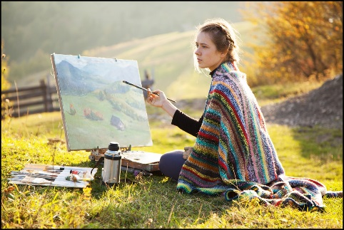  (________________)
Picture 4  (________________) | Picture 5  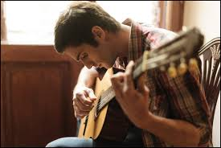  (________________) | Picture 6  (________________)

Do you know any other hobbies and interests?
Activity 3.2. What do you like doing?
Look at the pictures and the scrambled letters beside the pictures. Rearrange the scrambled letters to reveal the hobby or interest described in each picture. Look at number 1 as an example. (Perhatikan gambar dan huru-huruf yang diacak. Susun kembali huruf-huruf tersebut sehingga menggambarkan hobi atau minat sesuai gambar. Lihat nomor 1 sebagai contoh).
 | 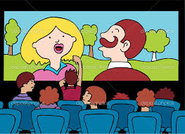 | 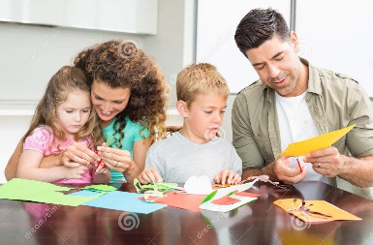
- GISNING | - WATCHING VOMIES | - RGAFTICN
(SINGING) | Watching (________) | (__________)

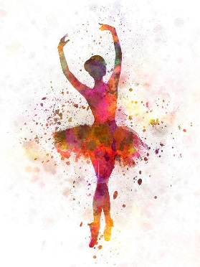
- AGNCDIN | - RSFINUG THE NET | - GTAELINRV
(__________) | (__________) the Net | (__________)

 | 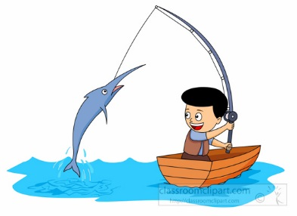
- GOING CGANMPI | - GOING ISFHIGN | - ROTSPS
Going (__________) | Going (__________) | (__________)

Let’s Master it
Model Dialog
Situation: Grace meets Matthew, her high school friend, at the movie theater.
Grace | : | Matthew? Is that you?
Matthew | : | Hi Grace. How are you?
Grace | : | I’m fine thank you. What about you?
Matthew | : | Pretty good. Thank you. So, do you like watching movies too?
Grace | : | Not really. I’m with my little brother James. He wants to watch “Superman Returns”. What about you? Do you like watching movies?
Matthew | : | Yes. I love watching movies. I go to movies at least once a month.
Grace | : | I see. What type of movies do you like?
Matthew | : | Comedy and action movies. And, Grace, what do you like doing in your free time?
Grace | : | Me? I like crafting and surfing the Net.
Matthew | : | Crafting? That’s interesting. What do you usually make?
Grace | : | I love paper craft, like origami. I make different kinds of things with paper, like a bookmark like this. Here, this is for you.
Matthew | : | Wow. Very nice. Thank you. You should teach me how to make like this next time.
Grace | : | Sure. Why not?  Well… here comes my brother. I have to go now, Matt.  Nice talking to you. Stay in touch. Bye.
Matthew | : | Okay, Grace. Nice talking to you too. Bye.

Activity 3.3. Comprehending the dialog
Read the dialog and answer the following questions and choose the best answer to each question. (Baca dialog dan pilihlah jawaban yang terbaik untuk tiap pertanyaan berikut).
No | Question | Answer
1 | Where are Grace and Matthew? | - Supermarket  - Movie theater  - Sports center
2 | Who is going with Grace to the movies? | - Matthew  - Grace’s brother  - She is alone
3 | Who is Matthew? | - Grace’s brother  - A stranger  - Grace’s friend
4 | Who likes watching movies? | - Grace  - Matthew  - Nobody
5 | What type of movies is his/her favorite? | - Horror and romance  - True story  - Action and comedy
6 | Who likes crafting? | - Grace’s brother  - Grace  - Matthew
7 | What does he/she make? | - Paper craft  - Pottery  - Leather craft

Language Expressions: Talking about hobbies and interests
Read the following expressions used to talk about hobbies and interests. (Bacalah ungkapan-ungkapan berikut untuk berbicara tentang hobi atau minat)
To ask for hobbies and interests, you can use the following questions: | - What do you like doing?  - What are your hobbies?  - What do you do in your free time?
To express hobbies and interests, you can say: | - I like watching movies.  - My hobby is gardening.  - I enjoy cooking.
To get more information about someone’s hobbies and interests, you can ask: | Ask about the type:  - What type of movies do you like?  - I like action movies.  - What type of craft do you make?  - I make paper craft.  Ask about the frequency of doing it:  - How often do you go to the movies?  - I go to the movies once a month.  - How often do you go swimming?  - I go swimming every Saturday.  Other questions:  - Who do you usually go to the movies with?  - I usually go to the movies with my sister.  - Who is your favorite author?  - My favorite author is Paulo Coelho.

Activity 3.4. Using language expressions
Rearrange the following words to make statements or questions about hobbies and interests. (Urutkan kembali kata-kata berikut untuk membuat kalimat atau pertanyaan tentang hobi atau minat).
- A: / free time?/do/ in/ What/ your/ you do/

____________________________________

B: I like cooking.

- A: /type of/What/ like/ to cook?/ do you/ food/

____________________________________

B: I enjoy cooking Indonesian food.

- A: / often/ do/ cook?/ How/ you/

____________________________________

B: I usually cook on weekends.

- A: / Indonesian dish?/ your favorite/ is/ What/

____________________________________

B: My favorite Indonesian food is Fried Rice.

- A: / your/ is/ Who/ favorite/ celebrity chef?/

____________________________________

B: My favorite celebrity chef is Farah Quinn.

Let’s Apply
Activity 3.5. Answering Questions
Choose the best response to each question below. (Pilih jawaban yang paling tepat untuk tiap pertanyaan berikut)
Dialog 1
- What’s your hobby?
- I don’t know anything about sports.
- Sport is good for your health.
- My hobby is doing sports.

- What type of sports do you like to do?
- Many people like swimming.
- I like swimming.
- Swimming is healthy.
Dialog 2
- What do you like doing in your free time?
- Photography is popular.
- Nature photography is beautiful.
- I enjoy photography.

- What type of picture do you like to take?
- I like taking pictures of animal and nature
- The view in the mountain is spectacular.
- Taking pictures is quite a difficult task.
Dialog 3
- What do you like doing on weekends?
- Shopping is my favorite weekend activity.
- Weekend is my favorite time of the week.
- I don’t like to go shopping on weekends.

- With whom do you usually do it?
- My sister loves going shopping.
- I go to big department stores.
- I usually go shopping with my sister.
Now, please try one short dialog with your partner.
- Student A: Ask your friend for his/her hobby/interest.
- Student B: Respond to your friend’s question. Then, ask him/her about his/her hobby/interest.

Activity 3.6. Mini Dialogs
Use the following cues to talk about hobbies or interests. Student A will ask question. Student B will answer the question. Look at the example. (Gunakan petunjuk yang diberikan untuk membuat dialog tentang hobi dan minat. Student A akan mengajukan pertanyaan. Student B akan menjawab pertanyaan. Lihat contoh yang diberikan)
Cue: (Cooking) Student A: What do you like doing in your free time?
Student B: I like cooking.
Student A: What type of food do you like to cook?
Student B: I like to cook Fried Rice.

- (going to the movies) :
- (making paper craft) :
- (photography) :
- (gardening) :
- (playing guitar) :
- (going fishing) :
- (surfing the net) :
- (painting) :
- (singing) :
- (drawing) :
Activity 3.7. On your own
Look at the model dialog. Prepare a similar dialog with your partner talking about hobbies/interest. Then, act it out in front of the class. (Lihat kembali contoh dialog di unit ini. Bersama dengan teman disamping anda, siapkan sebuah dialog pendek terkait topik kita hari ini. Setelah itu, role play-kan dialog tersebut di depan kelas.)
Let’s Review
Activity 8.9. Discussion questions
Please discuss the following questions. (Diskusikan pertanyaan berikut dengan teman di kiri/kanan anda).
- Can you mention different types of hobbies and interests that are new to you?

The types of hobbies and interests that are new to me are:
- ____________________________________________________

- ____________________________________________________

- ____________________________________________________

- Which hobbies/interests do you want to try or learn in the future? Why?

The hobby/interest that I want to try or learn in the future is: _________.

I want to try or learn it because _________________________________.

Let’s Take Note
Activity 3.8. Answering questions
Read the text and answer the questions below it. (Bacalah teks di bawah ini dan jawablah pertanyaan-pertanyaan di bawahnya)
TALKING ABOUT HOBBIES AND INTERESTS
Talking about hobbies and interests is not just a great way to make new friends. It is also a great way to include in our resume.
After we are introduced to a new friend, we usually want to continue the conversation to know more about them. Talking about hobbies and interests can be a great way to get to know each other more.
Adding personal interests and hobbies to your resume is also a great way to secure a post in a new job. A lot of companies will also look at this section to find out if your interests and hobbies fit in with their work culture. So, choose a relevant and unique hobby or interest that matches the company’s culture.
- What are the two important benefits of talking about hobbies and interests?
- What are your unique hobbies or interests?
What kind of companies do you think your hobbies or interests are in line with?

