LEARNING HOW TO E-LEARN EFFECTIVELY
Nowadays, technology has become an inseparable part of learning. In fact the role of technology to facilitate learning is becoming more and more part of everyday learning in all areas and levels of education and businesses. Therefore, it’s high time for everyone be involved in learning to learn how to e-learn effectively.
Effective e-learning requires specific skills, strategies, methods and applications and involves the learners in developing and extending their existing learning skills into new directions. For example, in conventional learning, a successful learner needs to be able to listen to presentations, lectures and discussions and be able to identify the key issues in a reading text. On the other hand, an e-learning student needs to read and analyze from a wide range of sources and media including many small informal e-mail messages.
Success in traditional courses does not always translate into success in online courses (Ray Watkins, 2013). Learners need to adopt and adapt new technology, strategies, skills and study habits.
Basically, there are two sets of fundamental skills that an e-learner needs to develop in order to learn effectively using technology:
- Online success skills
- Learner success skills

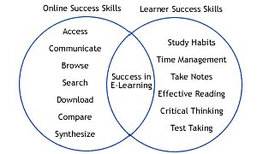

Relating Online Success with Traditional Student Success Skills
(Based on the E-learning Companion, Watkins & Corry, 2004)
Accessed from: Online Study Skills, college of management and technology,
https://online.dacmt-acquisition.org.uk/SelfDevelopment/OnlineStudySkills/tabid/139/Default.aspx)

Below is the learner-friendly version of e-learning success skills adapted from Watkins and Corry.

Online success Skills
Learning with the support of technology can be fun, fast and effective after you learn the basic technology skills to make e-learner technology literate, which involve the following e-learning success skills.
- Browsing and searching
Abundant information is available online. You just need the right key word(s) to type on the search engine to get you to the site you need. A search engine can help you locate any information about almost any subject you can think of in a split second.
For December 2012, the search landscape was like this:
- Google: 114.7 billion searches, 65.2% share
- Baidu: 14.5 billion searches, 8.2% share
- Yahoo: 8.6 billion searches, 4.9% share
- Yandex: 4.8 billion searches, 2.8% share
- Microsoft: 4.5 billion searches, 2.5% share
- Others: 28.7 billion searches, 16.3% share

(Source: searchengineland.com, accessed, August 12, 2013, 10:19 am)

- Accessing
Once you get to the web page that you want to explore, pay attention to the accessing policy.

- Free or Pay to view or download?
Some websites require a visitor to pay to view or download information. Others provide information free of charge.

- Credibility and Privacy
Check the credibility of the information provided in the web-site. Here are some tips from Palgrave Macmillan Publisher (palgrave.com)

  - Who produced the information?
Check the ‘owner’ by clicking the ‘About us’ tab which is usually placed on the home page.
  - When was the information updated?
Check the published and updated dates of the information you read. Some information is regularly updated.
  - What is the privacy or copy right policy?
Check the privacy or copy right policy which is usually placed towards the bottom of the web page.
  - Are there any Links?
Check links to other related sources to help you compare and contrast information. These links are also useful to evaluate the validity of content.

- Password or enrollment key
Some web pages, especially in-house e-learning web pages require a learner to access information with a password or enrollment key. Be sure to ask the lecturer or facilitator of the e-course you wish to enroll.

- Navigation key and tabs
Information in a website is classified into some headings under different ‘tabs’. Be sure to learn the navigation key and important tabs.

- Downloading
To learn more about a certain topic, you may need to download the article for further reading.
- Study the downloading procedures – some articles are published in pdf, ppt or doc. They need related applications to download. Other movie files require downloading application to be installed before downloading and running the program. Be sure to also check the ‘version’ of the program to run it smoothly.
- Check the downloading policy
Before downloading any materials from a website, check the copy right policy and take note of the sources (e.g. author, websites, publisher)

- Communicating
Learning using technology may seem like a solitary activity, but just like any other learning activity, e-learning involves communication with people. When communicating, a learner needs to pay attention to communication ethics.

- Online communication (Chat or discussion board)
Online chatting can be synchronous (real-time or live) or asynchronous (delayed communication).

- Synchronous communication provides online experiences that allow immediate responses, questions and comments from others.
- Asynchronous communication offers the opportunity to carry on communication with fellow e-learners or facilitators at times convenient to the e-learner.
When taking part in online communication (chat or discussion board) be sure that you can actively contribute in creating good study environment for the chat or discussion, follow the rules, agenda and etiquette guides posted by the facilitator.
- Email
Ryan Watkins (www.how2elearn.com) suggested the following tips for effective and ethical communication using emails.

- Prior to sending email messages, carefully proofread the message.
- In order for the recipient to open a file that you have attached to an email, be sure you saved your attachment using compatible software application.
- Review the ‘To:, CC:, and Bcc:’ fields before sending emails to make sure you send the email to the right people.
- Never leave the ‘subject’ field blank. Type the purpose or key subject of the email.
- It is good online etiquette to ask before sending emails with large file attachments since they may require the recipient to have substantial server space.
- Even when you have prior arrangement to send attachment with the recipient, never send a blank ‘email’ body – always write your message on the body of the email.
- When you are forwarding an email message that contains email addresses of multiple recipients, take time to remove those before forwarding the message and be sure what you are forwarding is appropriate and ethical.

Learner success skills
Once you get access to the materials you need, you can now apply the following e-learning study skills which:
- Study habits

- Time Management
Habits need to be developed. Thus, you need to allocate certain time that is most convenient to you for online learning.
  - Sufficient study time
Be sure to allocate sufficient study time for online learning: 30 minutes to 1 hour would be ideal. Beyond that will be tiring, thus needs breaks.
  - Time of day:
Some people prefer to study very early in the morning because it is the best time for them to concentrate. Others prefer to study in the afternoon or late at night.
  - Important dates: Be sure you are aware of important dates, such as dates for course registration, deadlines of assignments, tests, quizzes, and online communication. You can keep your online organizer ‘on’ to remind you of the important dates. There are many applications that you can use to help you with this: student.collegeboard.org, onlinestudentplanner.com, myschoolbinder.com, google.com/calendar, doodle.com (for group learning).

- Setting environment
Another important element for developing study habits is the study environment. Prepare healthy and comfortable learning environment for optimum result.

  - Place
Choose the most comfortable place where you can sit and learn. It can be in the comfort of your own bedroom, or a corner in the library.
  - Lighting
Adjust surrounding lighting to well fit your preferences. Some like to have a beam of light focusing the learning area, others like to have the room brightly lit.
  - Keep the Monitor on eye-level
Keep the monitor on eye-level so you can comfortably see the screen. If it is below eye-level, you may put your neck at risk. If it is above eye-level, you may sit at a strange angle, even slouch—this may eventually give you back pain.

Another thing to keep in mind, is to maintain distance between the eyes and the monitor at a comfortable distance.

  - Minimum Distraction
Be sure to keep the distractions minimum, for example: put your mobile phone on silent mode, turn off chat mode, keep yourself away from online game sites.

- Self-Discipline and motivation
In conventional learning, you learning time and classroom sessions are clearly timetabled for you. In addition, the lecturers may remind you of assignments, quizzes and tests. Learning online requires you to have self-discipline to complete tasks, take tests, and submit assignments on time.

So, get organized and remain positive to develop self-discipline and maintain your motivation to complete all tasks, tests and assignments.

- Independent Learning and Critical Thinking
In conventional way of learning, you can directly ask your lecturer or fellow students if you have questions. In e-learning, you need to rely more on your critical thinking skills to be independent learners.

Some basic critical thinking skills that you may need to apply are as follows:
- Learning goals and questions
Before you even embark on your e-learning journey, it will be helpful to start with goals and questions in mind. These goals and questions can serve as guidelines to search for information, select important key ideas and structure your learning accordingly.

- Organizing
Information is abundant online. You need to organize the information to help you understand and remember better. Organizing information requires you to sort, group, and select important ideas to fit your learning goals. There are many tools that you can use to do this. One way of organizing information is using mind-mapping.

- Effective Reading Skills
In e-learning, you will need to read a lot of materials: articles, videos, powerpoint presentations in limited time. Thus, you will gain a lot if you apply effective reading skills.
- Previewing
Before you start reading, preview the title, subheadings, introduction and conclusions to get the overview of what you are going to read and to locate the information you need.

- Deciding what to read
After previewing you can then decide whether you need to read the article or find another article that fits your learning goal.

- Identifying main ideas
The next step is identifying the main ideas of the materials you wish to learn. You can organize these ideas in an outline form, list them down, or make an outline.

- Paraphrasing
As you read the article, you may find important part to record as it is or paraphrase in words that make more meaning to you.

- Identifying facts and opinions
Information that you read consists of facts and opinions. It is useful if you can distinguish facts from opinions to help you understand the article better and make better judgment of the issues discussed.

- Summarizing
One way of recording the information read is by summarizing. Summaries help you recall the important points later.

- Note-taking
When learning online, note-taking (which is also part of effective reading) becomes an important part of learning to record information and to help you internalize what you read by putting them into your own words. This will help you remember the materials better because you have actively thought about them as you take notes.

When taking notes, there are some things to keep in mind.
- Personal
The notes you make are personal to you, so they need to be in a format that suits the way you learn.
- Clear
The notes help you to remember information. Thus, they need to be clear, easy to read and accurate.
- Comprehensible
The notes should help you understand information. Therefore, it is necessary that they be well-organized (use a system to record information) to be easily and comprehensibly retrieved.
- Brief
You need to make your notes brief without losing the meaning and value of the information recorded.
- Examples and illustrations
Be sure that you note down examples and illustrations that help illuminate they key points that you wish to learn

Ways of taking notes
There are two ways of note-taking: passive and active note-taking.
- Passive note-taking
When you take note passively, you do the followings:
    - Underlining and highlighting information
    - Cutting and pasting information
    - Copying direct quotes or texts

- Active note-taking
Active note-taking involves critical thinking and effective reading skills
- Asking and answering questions
- Identifying main ideas
- Organize ideas
- Comparing and contrasting ideas/information
- Evaluating and commenting on issues discussed

Methods of note-taking
Note-taking is personal, thus, there’s no right or wrong way of taking notes. However, there are five methods from redlends.edu (http://www.redlands.edu/docs/StudentLife/1Five_Methods_of_Notetaking.docx_UPDATED_7-09.pdf) that are given here as examples. Choose the one that fits your style.
- Cornell method
This method divides your notes into two columns. The first column is for the key points. The next column is for the examples or brief explanation of the key point in the first column.

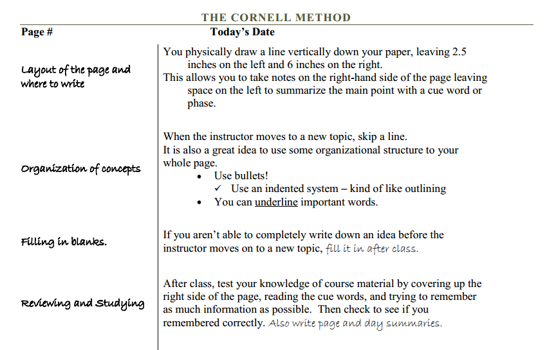

- Outlining Method
In outlining method, you can list down the key points and their brief explanation in an outline form.
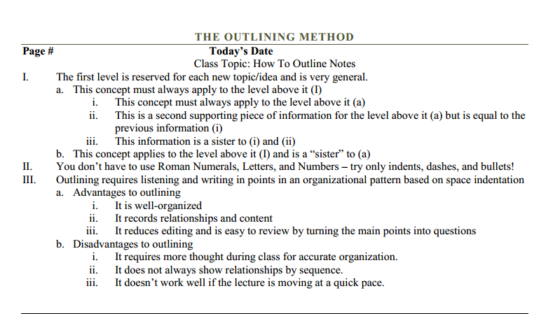

- Charting Method
The charting method enables you to group information in table or chart form to make it easy to read and retrieve.

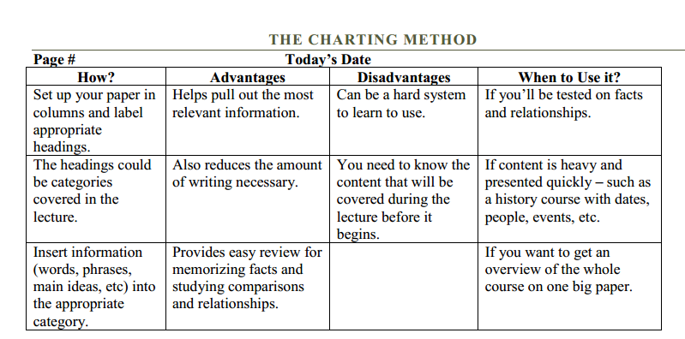

- Mapping Method
Mapping method organizes information in the form of a mind map. You can also use free online mind-mapping tools to help you make effective notes.

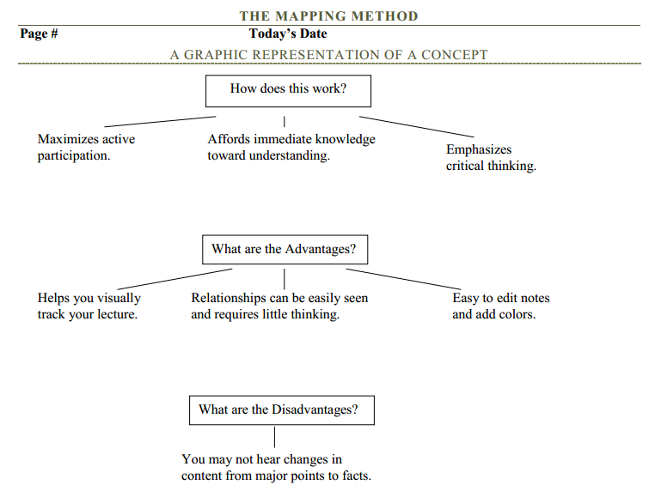

Here are the top three free mindmapping tools suggested by imdevin.com:
    - Bubble.us (https://bubbl.us/): It’s simple, easy and provides a lot of free training.
    - Mind42.com (http://mind42.com/): It’s first class, fun, free and fully featured.
    - Labyrinth.com (https://people.gnome.org/~dscorgie/labyrinth.html): it’s a simple basic easy to use mind mapping software for Linux and windows, and widely available too. It makes it easy to add images and offers a simple way to add notes.

For more information about suggested free mind mapping tools, click the following link: imdevin.com (http://www.imdevin.com/top-10-totally-free-mind-mapping-software-tools/)

- Sentence Method
In a sentence method, the information is written in sentences. Each sentence or group of sentences can be numbered or bulleted.

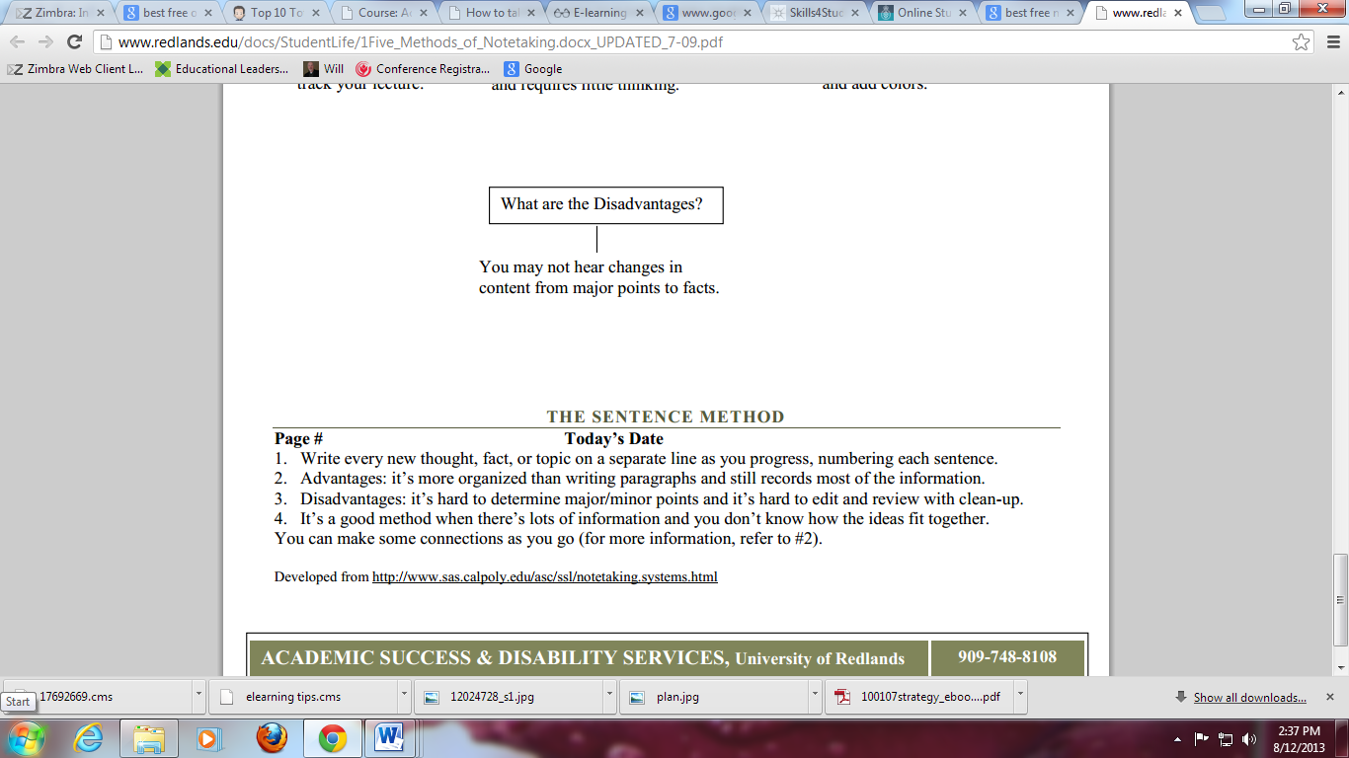

- Test-taking
Another important skill of effective e-learning is test taking skills.
- Timed tests: In e-learning, the tests are usually timed.
- Objective tests: Many of the tests are objective tests (Multiple choice, drag and drop, filling in the blanks, or True/False statements)
- Essay tests: Some tests require you to write your answer which will then manually graded by the evaluator.
- Instructions: Before you take the test, be sure you understand the instructions well.

The important issue to remember about e-learning is that it is LEARNING. Only that it is facilitated by technology. So, the soul of e-learning is LEARNING. Learning is successful if it involves changes. When you e-learn, be sure it involves changes to make you better. All the best.

God bless you!

Let the wise hear and increase in learning, and the one who understands obtain guidance, (Proverbs 1: 5)

