MEETING HOSPITAL STAFF
LEARNING OBJECTIVES
- Different departments or units in the hospital
- Different types of medical professionals working in the hospital
- Introducing oneself to other medical professionals
- Making small talks
PRE-LEARNING: VIDEO WATCHING
Choose one video to watch (in the blog) and answer the following questions:
Tell us in 3-5 sentences about the video? (the name of the person, the job of the person, what he/she likes about the job, what his/her advice)
WARMING UP
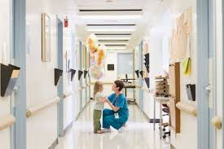
Look at the picture.
- How many people do you see in the picture?
- Who are they?
- Can you mention some professions you can find working in the hospital?
- Where are they?
- Can you name some units or departments in the hospital?

VOCABULARY ACTIVITIES
Activity 1: Different departments or units in the hospital (Pair Work)
Match the departments or units in the hospital below with the descriptions of services offered in each department.
Hospital Departments
- Accident and Emergency | H. Neurology | O. ENT
- Cardiology | - Obstetrics | P. General Surgery
- Chaplaincy | J. Oncology | Q. Haematology
- Critical Care | K. Opthamology | R. Maternity
- Dermatology | L. Orthopaedics | S. Pathology
- Diagnostic Imaging | M. Paediatrics | T. Urology
- Physiotherapy | N. Renal Unit | U. Pharmacy

Health care services offered
No | Department | Descriptions
1 |  | deals with sick children.
2 |  | gives intensive care to critically ill patients
3 |  | specializes in treating heart diseases.
4 |  | treats diseases of the skin.
5 |  | gives care to patients with eye, nose and throat problems.
6 |  | operates 24 hours to deal with all cases of emergencies
7 |  | studies blood disorders.
8 |  | performs a full range of imaging such as x-ray scans, mammography, ultrasound scan, angiography (x-ray for blood vessels), CT Scan (Scan that shows cross-section of the body) and MRI (3D Scan).
9 |  | provides antenatal care, care during childbirth and post-natal support.
10 |  | studies illnesses and analyzes samples.
11 |  | specializes in pregnancy and birth.
12 |  | performs operations on patients.
13 |  | provides services to treat eye problems.
14 |  | deals with disorders of the nervous system, including the brain and spinal cord.
15 |  | treats kidney diseases.
16 |  | provides drug-based services.
17 |  | treats injuries and diseases of the musculoskeletal system, which includes bones, joints, ligaments, tendons, muscles and nerves
18 |  | provides spiritual and pastoral care to patients, relatives and staff
19 |  | designs special exercises for patients.
20 |  | provides cancer care treatment.

Activity 2: Hospital team (Individual work)
Match each picture of a profession in a hospital with the job descriptions.
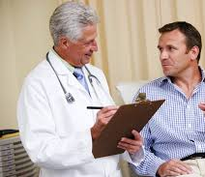  A | B | C
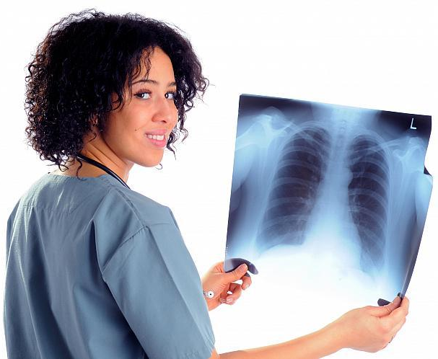  D | 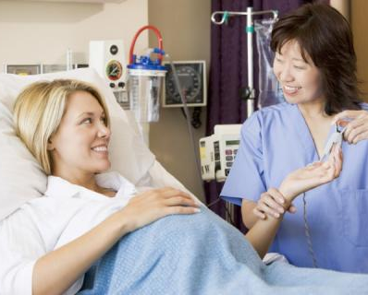  E | 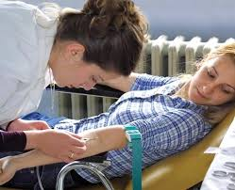  F
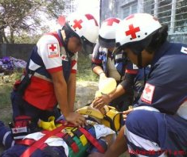  G | H | 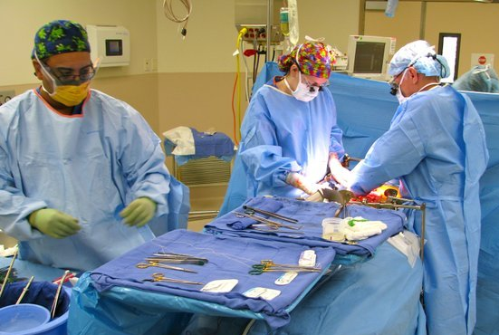  I
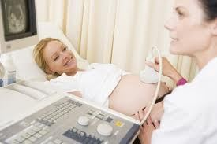  J | K | 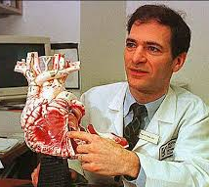  L
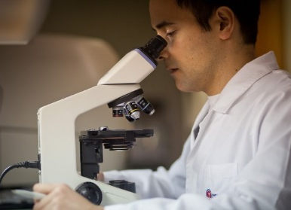  M | N | 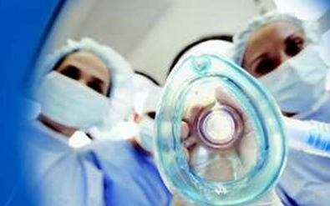  O

No | Photo | Descriptions
1 |  | Anaesthetist – puts people to sleep before surgery.
2 |  | Cardiologist – deals with disorders of the heart and blood vessels.
3 |  | Midwife – delivers babies/helps pregnant women.
4 |  | Lab Technician – analyzes body fluids/medical tests.
5 |  | Paramedic – a person trained to give first aid to the patients with the aim of stabilizing them before being admitted to the hospital.
6 |  | Pharmacist – prepares and gives medicines for patients.
7 |  | Paediatrician – doctor who specializes in babies and children.
8 |  | Physiotherapist – helps the patients to move again after na injury.
9 |  | Radiologist – takes and analyzes x-rays.
10 |  | Surgeon – performs surgery.
11 |  | Obstetrician – specializes in pregnancy, labor, and pueperium (the time-period directly following childbirth).
12 |  | Nurse –works in a variety of settings to provide and manage the care of individual patients. They work closely with doctors and other healthcare professionals
13 |  | Phlebotomist – takes blood from patients in wards or outpatient clinics for examination in laboratories.
14 |  | Doctor – diagnoses symptoms and recommend treatment for patients. They have a wide range of clinical experience ranging from newly qualified junior doctors to senior consultants.
15 |  | Dietitian – works with people to promote nutritional wellbeing, prevent food-related problems and treat disease.

MODEL DIALOGS AND DIALOG PRACTICE
Model Dialog
Adams | : | Hello. Good morning.  I don’t believe we’ve met.  I’m dr. Brian Adams.  I’m in Intensive Care Unit at Star Hospital, New York.
Harrison | : | Hi. Pleased to meet you, doctor.  I’m Nurse Barbara Harrison from Sun Hospital, Ontario, Canada. I’m in Pediatric Unit.
Adams | : | Pleased to meet you too, Nurse.
Harrison | : | So, you are working in Intensive Care unit. How long have you been working in this unit?
Adams | : | About 5 years. What about you? How long have you been working in Pediatric Unit?
Harrison | : | Just 3 years. Nice talking to you, dr. Adams.  Well, we have to go back to the seminar room. The seminar will start again in 5 minutes.
Adams | : | Okay. Let’s go inside.
Language Expressions
- Greetings

Hello.
Hi.
Good morning/afternoon/evening.

- Introducing oneself

- Name, profession, department, hospital, city, country
- Pleased to meet you/Happy to meet you/Nice to meet you

I’m Nurse Alberto da Silva. I work in the Critical Care unit of Sunrise Hospital in Rome.
Pleased to meet you

- Responding to an introduction

Hello, Nurse da Silva.
Pleased to meet you too.
I’m dr. William Costner. I’m an anesthetist working in the General Surgery Department of Green Hospital, Sydney, Australia.

- Small talks
After introducing ourselves, we usually continue with small talk (informal talk) to get to know each other better.

Some topics to discuss in small talks:
- Talk about the job

How long have you been a/an (job)?
What do you exactly do in the hospital?
What do you like about your job?

- Talk about the company

How long have you been working in the hospital?
What kind of hospital is your hospital?
How big is your hospital?

- Talk about the place where you are from

I see. You are from Nairobi. Where is it?
Is it a big city?
What is the place famous for?
How long have you been working there?

- Talk about the place you are in at the time of speaking

When did you arrive here?
What places have you visited here?

- Talk about the event you attend together
Is this your first time attending this seminar/conference?
What do you think about the presenter/topic of the seminar?

- Ending a conversation

Nice talking to you. Nice talking to you too.
I have to go now. See you again soon. Okay. Bye.

PRACTICE
Activity 3: Introducing ourselves
Use the following clues to introduce yourself.
For example:
Clues: Brian Adams/doctor/Intensive Care Unit/Star Hospital/New York.
Good morning,
I’m dr. Brian Adams.
I’m in Intensive Care Unit at Star Hospital, New York.
Pleased to meet you.

Now, try it. Take turn to introduce yourself as the following people.
- Anita Brown/Nurse/Paediatrics/Siloam Hospital/Jakarta.
- Thomas Green/Pharmacist/Pharmacy/Johnson and Johnson Hospital/Canada.
- Susan Grey/Midwife/Maternity/Chicago General Hospital/Chicago
- David Livingstone/Surgeon/General Surgery/Cape Hope Hospital/South Africa.
- Melisa Nielsen/Dietitian/Paediatrics/Nairobi General Hospital/Nairobi.
- Lisa Delano/Dentist/Dentistry/Good Health Hospital/London/UK.
- Kevin Smith/Lab technician/General Hospital/Bangkok/Thailand
- Cathy Jones/Anesthetist/Jefferson Hospital/Washington DC/USA
- Takashi Nakamura/Chaplain/Mount Fuji Hospital/Tokyo/Japan
- (Your name)/Nurse/Siloam Hospital/Lippo Karawaci
Activity 4: Role Play
Now, find a partner and prepare a dialog.
CLOSING
So, when you meet someone new at work, what do you say to
- Greet others?
- Introduce your name?
- Talk about your profession?
- Talk about Unit/department?
- Introduce your Hospital?
- Talk about the City/country where you work
What topics do you discuss as a follow up to the introduction?
- Job
- Unit/department
- Hospital
- City/country of origin
- The place where you are now
- Others?

POST LEARNING:
If you are given the chance and the facilities to build your own hospital. What kind of hospital do you want to build (General Hospital or specialized hospital)? What city/country do you want to build the hospital in? Tell us more about your dream hospital. (1 paragraph of 5-10 sentences).

